CPU Scheduling Comparison Project Documentation
This document presents the implementation and comparison of three CPU scheduling algorithms: Round Robin (RR), Shortest Job First (SJF), and Shortest Remaining Time First (SRTF). The project compares all three algorithms using the same workloads and evaluates their performance using scheduling metrics such as Waiting Time (WT), Turnaround Time (TAT), and Response Time (RT).

Team Information

Member Name | Student ID
ابراهيم محمد اسماعيل عبدالعزيز بحيري | 20240011
احمد حسام الدين محمد ابراهيم عبدربه | 20240027
عبدالرحمن ياسر سمير ابراهيم | 20240566
حبيبه محمد محسن زكي | 20240282
نوران طلعت عبدالمنعم | 20241073
اسراء محمد عبدالحكيم | 20240127

Algorithms Used
Round Robin (RR):
Round Robin distributes CPU time fairly between processes using a fixed time quantum. Each process receives a small portion of CPU time before the scheduler switches to the next process.
Shortest Job First (SJF):
SJF selects the process with the shortest burst time first. It improves efficiency and usually reduces average waiting time
Shortest Remaining Time First (SRTF):
SRTF is the preemptive version of SJF. It always selects the process with the shortest remaining burst time and can interrupt a running process if a shorter job arrives. This improves response time and reduces waiting time for short processes.

Scheduling Metrics
- Waiting Time (WT) = Turnaround Time - Burst Time
- Turnaround Time (TAT) = Completion Time - Arrival Time
- Response Time (RT) = First Start Time - Arrival Time

Test Scenarios

Scenario A - Normal Workload
This scenario demonstrates normal execution using multiple processes with different arrival and burst times.
Quantum = 2
P1 Arrival = 0 Burst = 5
P2 Arrival = 1 Burst = 3
P3 Arrival = 2 Burst = 4 Result:SRTF achieved the lowest waiting time.

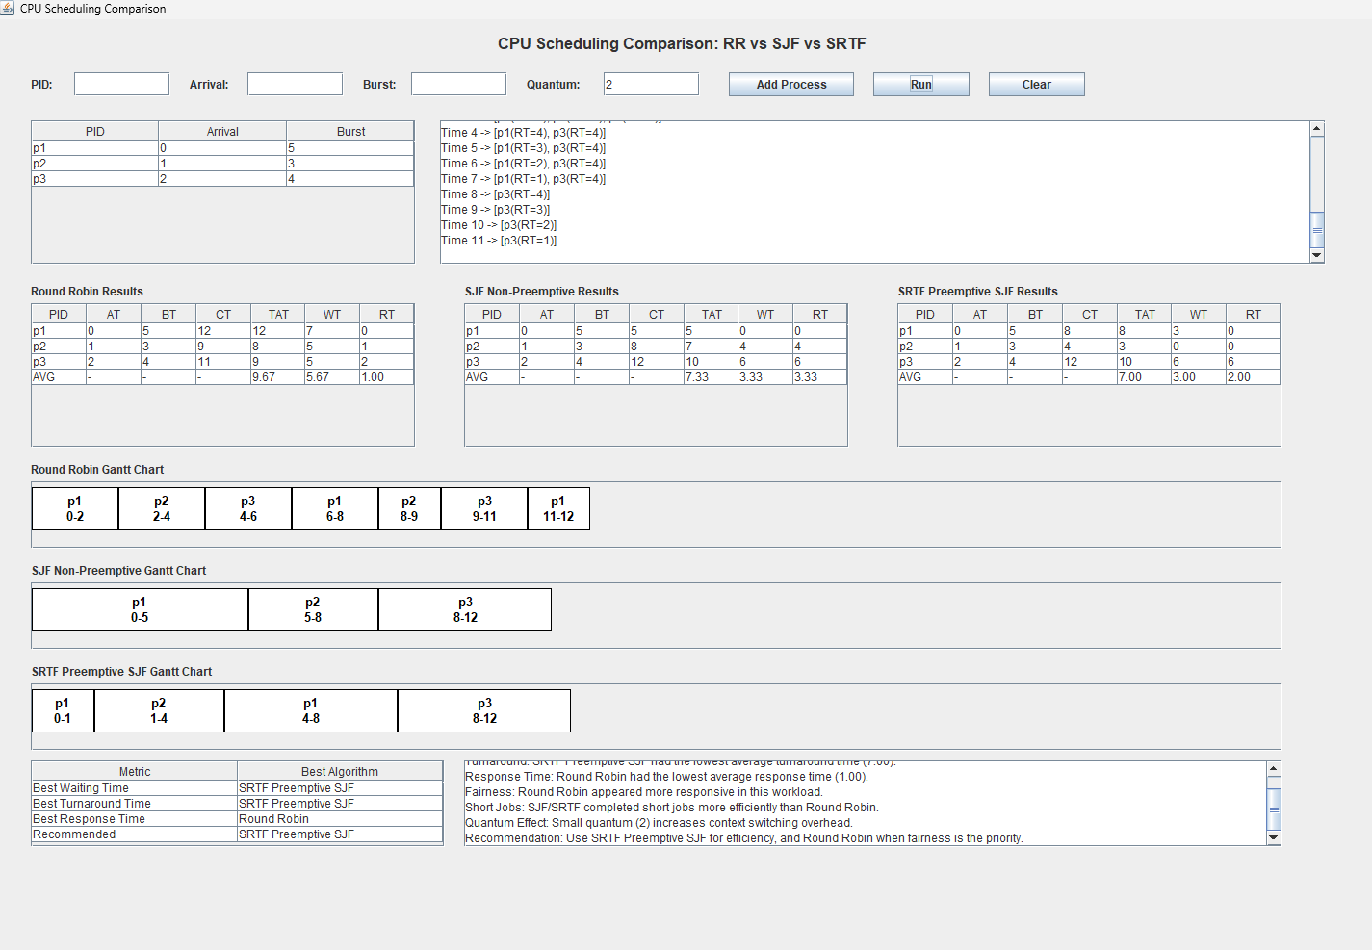

Scenario B: Short Jobs
This scenario shows why SRTF performs better than SJF when short processes arrive during
execution.
Quantum = 2
P1 Arrival = 0 Burst = 10
P2 Arrival = 1 Burst = 1
P3 Arrival = 2 Burst = 1
Result: SRTF achieved the lowest waiting time (0.67). SJF performed worst (WT=6.0) because it could not preempt the long P1 process.

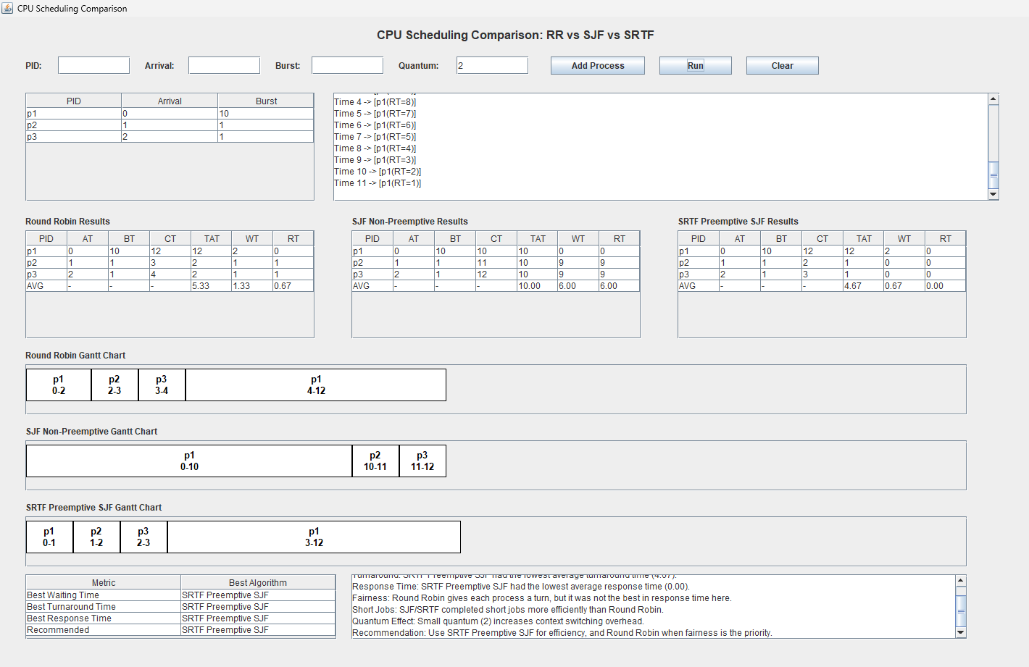
Scenario C: Long Job Sensitivity
This scenario demonstrates how SJF/SRTF may delay long processes when shorter jobs continue to arrive.

Quantum = 2
P1 Arrival = 0 Burst = 20
P2 Arrival = 1 Burst = 2
P3 Arrival = 2 Burst = 2
Result: Long process is delayed, showing possible starvation in SJF/SRTF.

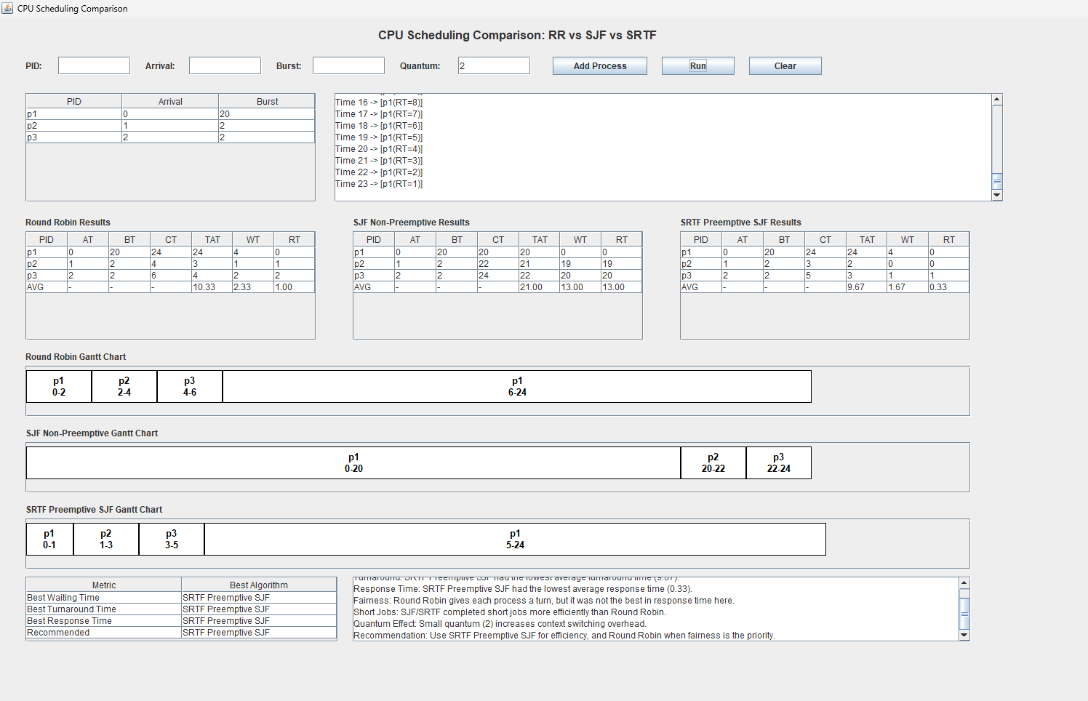

Scenario D: Fairness
This scenario demonstrates how Round Robin distributes CPU time fairly among processes with equal burst times.
Quantum = 2
P1 Arrival = 0 Burst = 10
P2 Arrival = 0 Burst = 10
P3 Arrival = 0 Burst = 10
Result:Round Robin distributes CPU time equally and is more fair

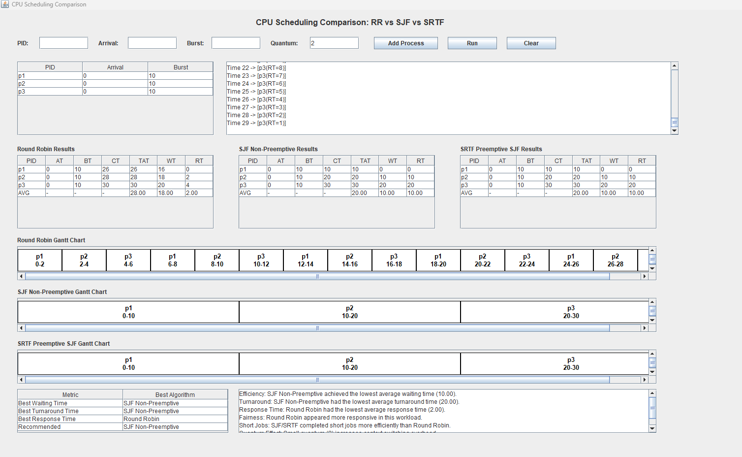

Scenario E: Input Validation
This scenario demonstrates input validation using invalid values such as negative burst time or invalid quantum.

Invalid Inputs:
Burst = -1
Arrival = -2
Duplicate PID
Quantum = 0
Result: The system correctly rejects invalid inputs.

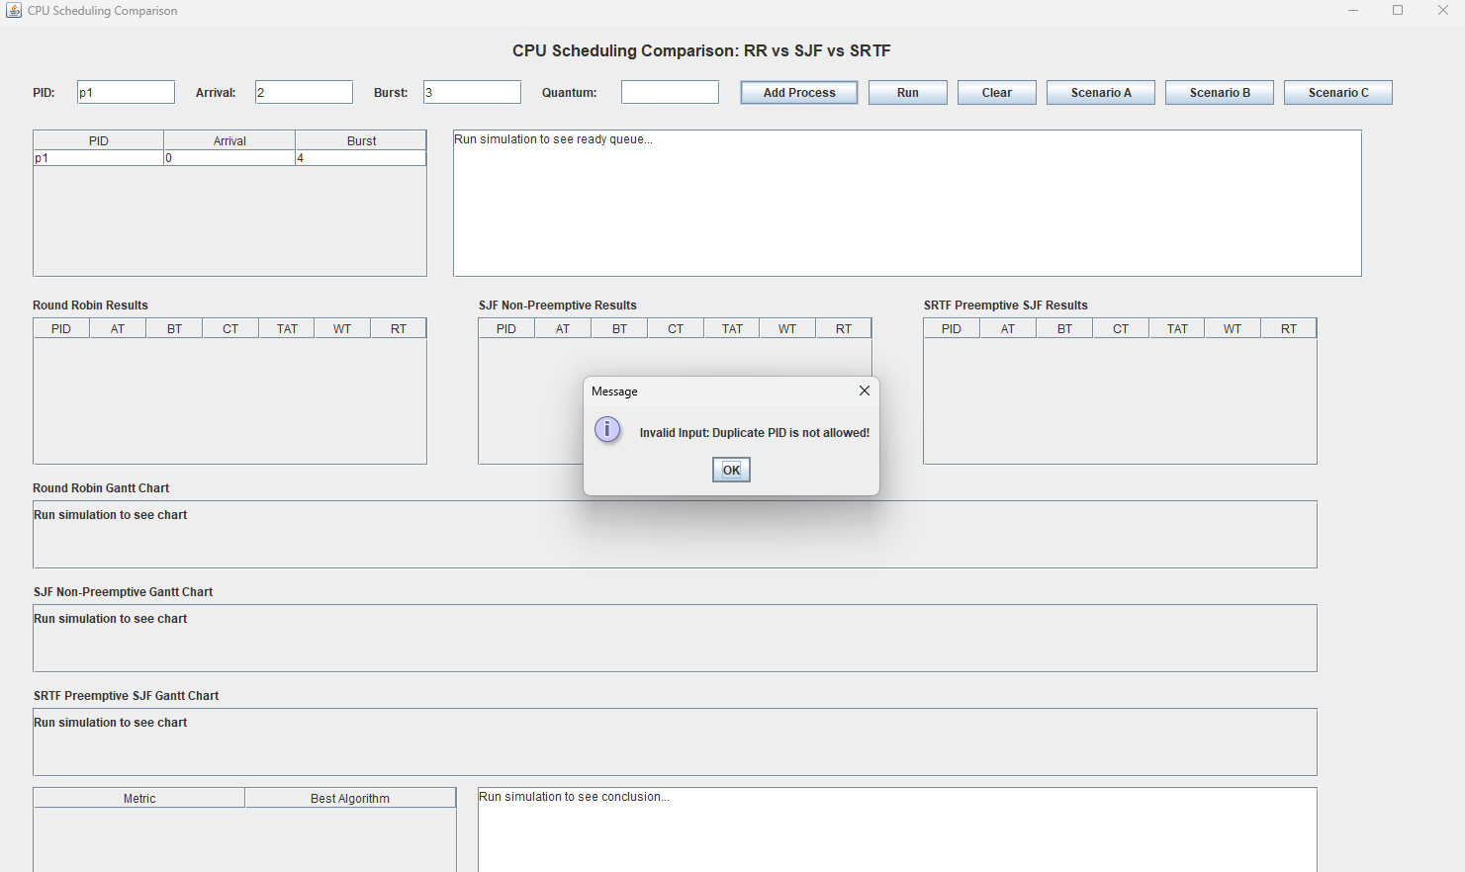

Comparison Between Algorithms
Metric | Round Robin | SJF
Fairness | High | Lower
Waiting Time | Usually Higher | Usually Lower
Response Time | Better | May Be Higher
Efficiency | Balanced | High

Required Analysis Questions
- Which algorithm gave lower average waiting time?
- Answer: SRTF usually gives the lowest average waiting time because it always preempts in favor of the shortest remaining job. SJF also performs well in non-preemptive cases. Round Robin typically has higher waiting time but better fairness.
- Which algorithm gave lower average response time?
Answer: Round Robin provides the best response time because every process receives CPU time quickly in turns. SRTF also provides good response time for short processes. SJF Non-Preemptive has the worst response time since processes may wait long before their first execution
- Did Round Robin appear fairer?
Answer: Yes, because CPU time is distributed equally among processes using time slicing.
- Did SJF complete short jobs more efficiently?
Answer: Yes, SJF strongly favors short jobs and usually completes them faster.
- How did the selected quantum affect Round Robin behavior?
Answer: Smaller quantum increases context switching while larger quantum makes RR behave closer to FCFS.
- Which algorithm would you recommend and why?
Answer: SRTF is recommended when efficiency and minimum waiting time are the priority. Round Robin is recommended when fairness and fast response time are needed, such as in interactive systems. SJF is a good middle ground for batch systems where preemption is not available.

Conclusion
The project successfully compared Round Robin, SJF Non-Preemptive, and SRTF (Preemptive SJF) scheduling algorithms using the same workloads. SRTF achieved the best efficiency and lowest waiting time across most scenarios. SJF provided good efficiency for non-preemptive cases but showed starvation risk for long processes. Round Robin provided the best fairness and response time by distributing CPU time equally among all processes. The project demonstrated how preemption, time quantum, and scheduling strategy affect CPU performance and process behavior.

